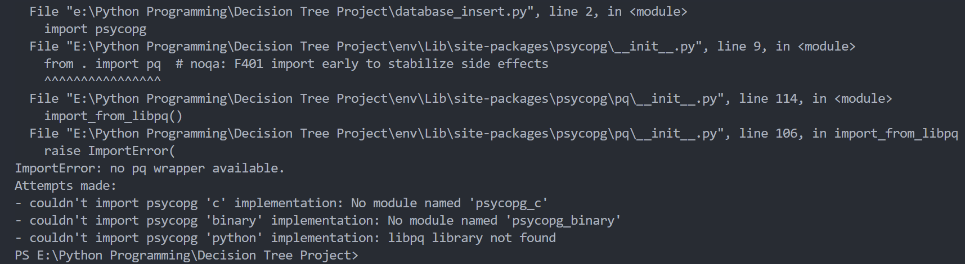

Solution :

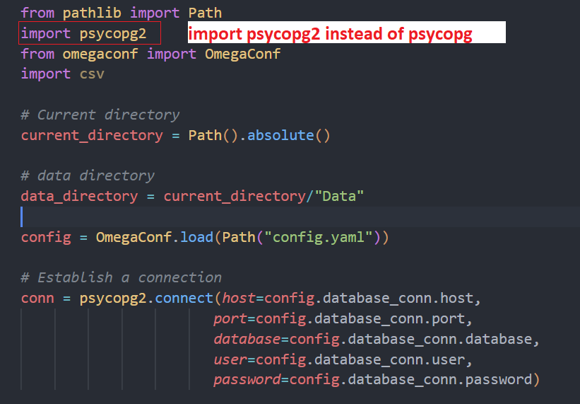

2. While accessing the database through SQL Alchemy Jupyter Notebook issue



Solution :

The below code has to be in 1 line

